### <Project Name>

Software Development Plan (SDP)

**SEMESTER MARCH-AUGUST 2025**

**GROUP: KCDCS1104A/B/C/D/E/F/G/H**

**Name 1, student number 1**

**Name 2, student number 2**

**Name 3, student number 3**

Revision History

|  |  |  |  |
| --- | --- | --- | --- |
| **Date** | **Version** | **Description** | **Author** |
| <dd/mm/yyyy> | <x.x> | <reason to change the documentation contents> | <name> |
|  |  |  |  |
|  |  |  |  |
|  |  |  |  |

Table of Contents

**1. Introduction 4**

1.1 History of Organization 4

1.2 Organizational Chart 4

1.3 Current System Description 4

1.4 Current System Problem 4

**2. Proposed Project Overview 5**

2.1 Proposed System Process 5

2.2 Proposed System Objectives 5

2.3 Proposed System Scopes 5

2.4 Proposed System Entity and Attributes 5

**3. Project Organization 6**

3.1 Organizational Structure 6

3.2 Roles and Responsibilities 6

**4. Management Process 7**

4.1 Project Plan 7

**Appendix 8**

Software Development Plan

# 

# Introduction

## History of Organization

Brief the history of the organization, vision, mission, (3 – 5 paragraphs).

Provide a SWOT analysis.

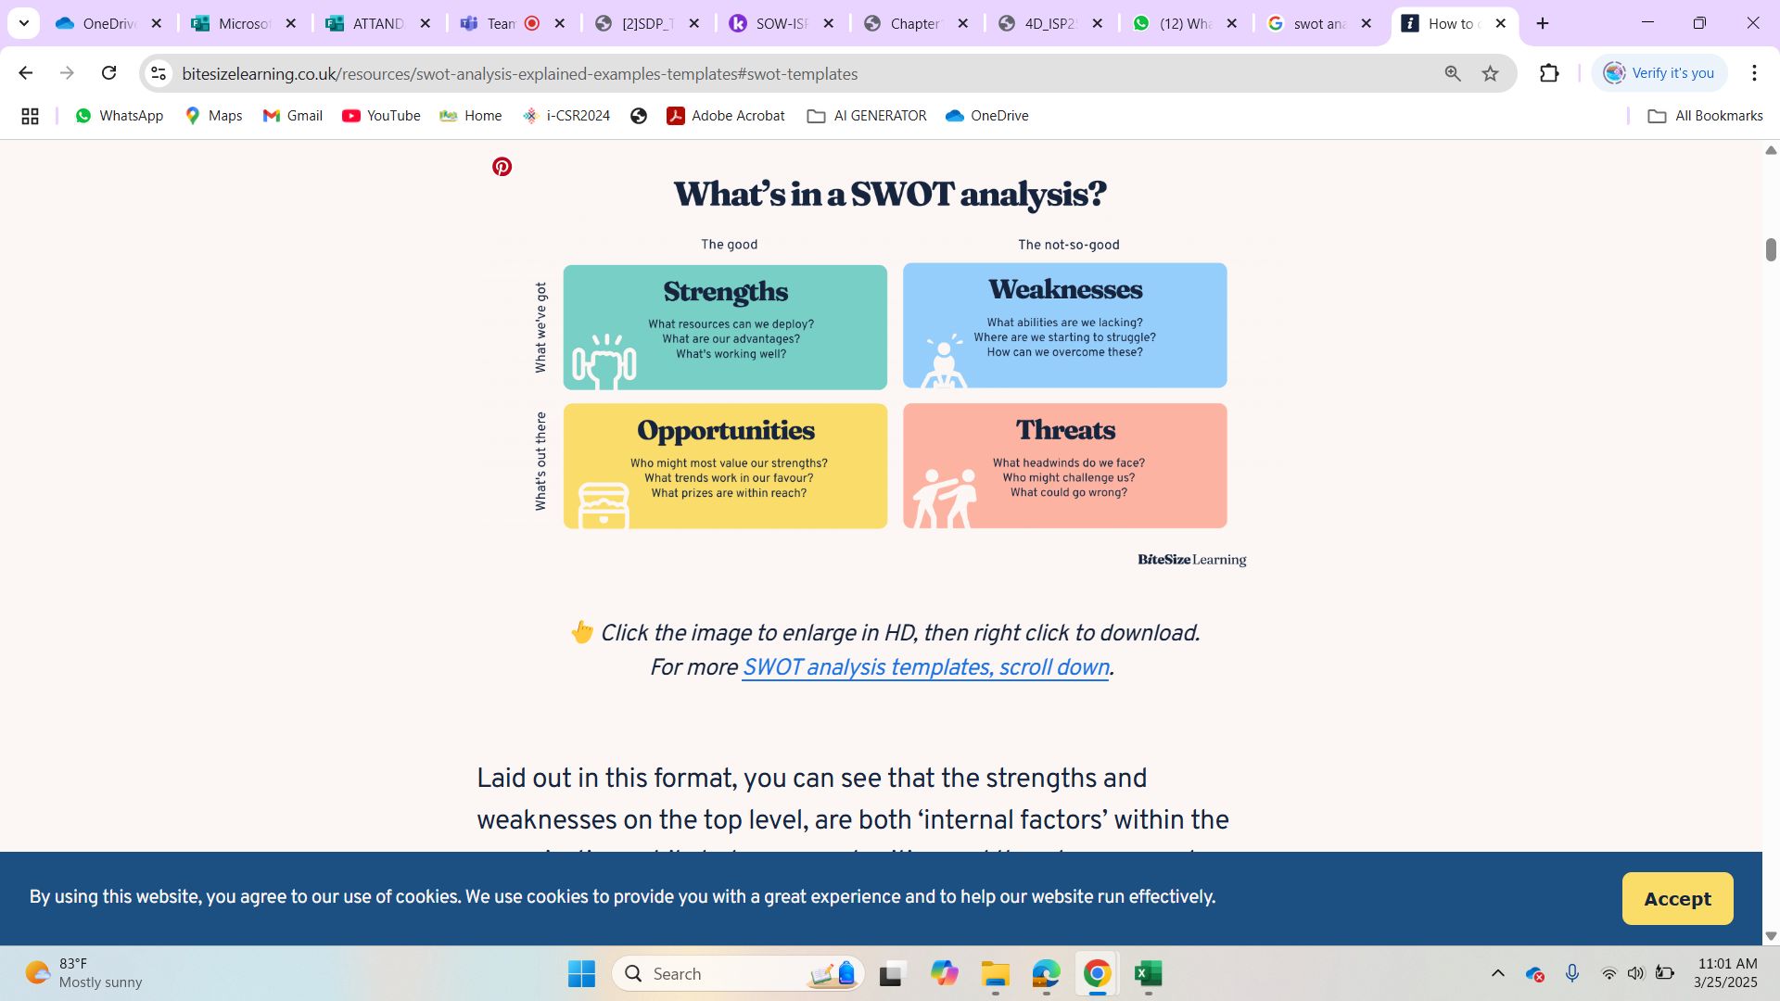

Refer Folder Lab = W01 DOCUMENTATION TOOLS.pptx

## Organizational Chart

Provide the hierarchy of the organization (provide diagram in appendix).

## Current System Description

Specify the description of all processes involved in the organization (2 – 3 processes). For a better understanding, you may provide a flow chart/business process modelling.

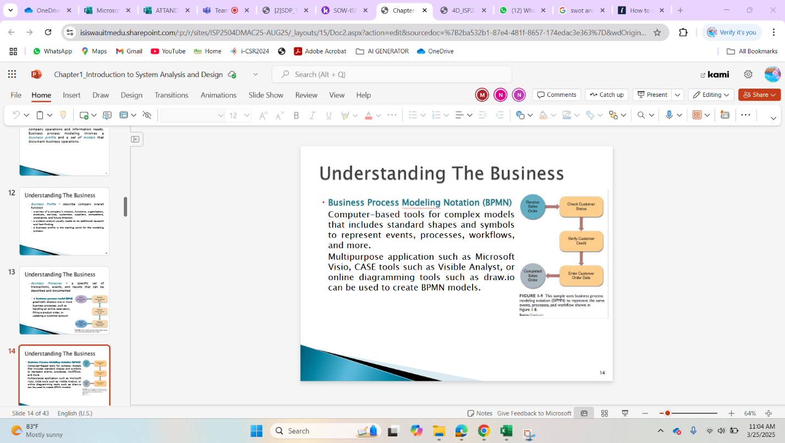

Refer Folder NOTES -- Chapter1_Introduction to System Analysis and Design.PDF

## Current System Problem

Specify 2 – 3 (4) current problems faced by the organization that could be solved bhjjjjjuuy implementing i/s (depends on the processes you have chosen).

Provide fishbone diagram, or Ishikawa diagram

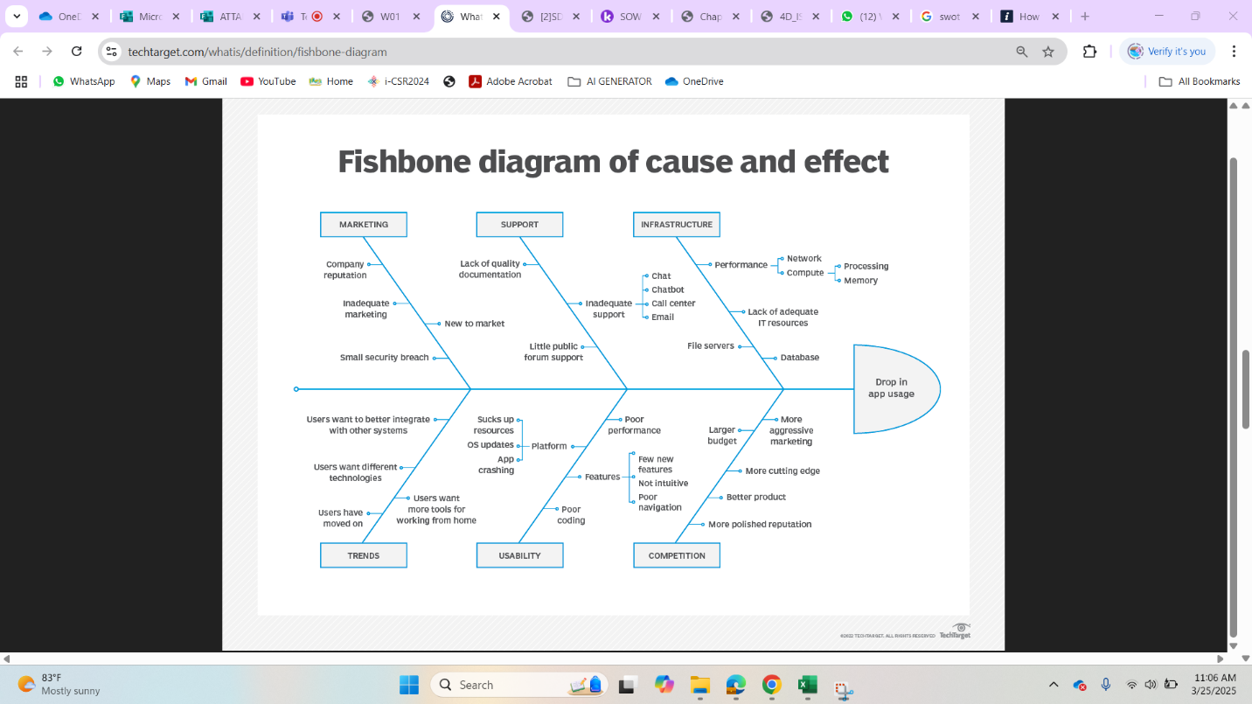

Refer Folder Lab = W01 DOCUMENTATION TOOLS.pptx

# Proposed Project Overview

## Proposed System Process

Provide a process which you propose based on the current problems above and current system processes you have chosen as above. For a better understanding, you may provide a flow chart.

## Proposed System Objectives

What your product/information system (IS) can provide to users based on the processes you have chosen above.

* To analyse ....... current process .... @ organization
* To design a web-based information system for .........
* To develop a web-based information system for ........

## Proposed System Scopes

Who are your stakeholders (user of the system) and the limitation of your product/information system (IS).

* Admin of the system are ...
* Process that could be done for admin in the proposed system
  + Admin can add/ edit menu
  + Admin need to verify order
* Customer are students inside uitm kedah
  + Customer need to register to the system
  + Then they can proceed with order process

## Proposed System Entity and Attributes

Provide Entity Relationship Diagram (ERD) in appendix.

* *5 / 6 TABLES FOR YOUR DATABASES*

# Project Organization

## Organizational Structure

Describe the organizational structure of the project team (Project Manager, Database Designer, Programmer 1, Programmer 2, System Analyst, and supervisor among lecturers.

## Roles and Responsibilities

Provide your group member’s formal picture and their responsibilities with job designation.

# Management Process

## Project Plan

*Provide a Gantt chart (in appendix) showing the allocation of date to the project/product/information system phases, identify the major milestones with their achievement criteria and who are responsibility for each phase. Provide 1 paragraphs of description. Copy paste your gantt chart.*

# Appendix

MANUAL FORM ON THE PROCESS

IMAGE ON INTERVIEW SESSION AND DETAILS ON PERSON IN CHARGE